TMRC ISLAMABAD

INTERNSHIP TASK 4:
Handwritten Digit Recognition using Neural Networks.

PROJECT REPORT
STUDENT NAME: M.Talha Wali Khan
INTERNSHIP: TMR CONSULING ISLAMABAD
DATE: 24 September 2026.

This report presents a simple neural-network-based system for recognizing handwritten digits from the MNIST dataset. The project covers dataset exploration, visualization, preprocessing, model training, evaluation, prediction, and model saving.
QUESTIONS.
Q1. What is handwritten digit recognition?
Answer: It is a computer vision task in which a machine learning model identifies a handwritten number such as 0, 1, 2, up to 9 from an image.
Q2. What is MNIST?
Answer: MNIST is a widely used dataset containing grayscale images of handwritten digits. Each image represents one digit from 0 to 9.
Q3. Why is preprocessing needed?
Answer: Preprocessing converts the raw pixel values into a suitable format for the neural network, for example by scaling pixel values from 0–255 to 0–1.
Q4. What is a neural network?
Answer: A neural network is a machine learning model made of connected layers of neurons that learn patterns from training data.
Q5. What is an epoch?
Answer: An epoch is one complete pass through the training dataset during model training.
Q6. What is accuracy?
Answer: Accuracy is the proportion of predictions that are correct out of all evaluated predictions.
Q7. Why save the trained model?
Answer: Saving the model allows it to be reused later for prediction without training the neural network again.
MNIST Dataset Explanation.
The MNIST dataset is commonly used for learning image classification. It contains handwritten digit images represented as 28 × 28 grayscale pixels. Each image has a corresponding label from 0 to 9. The pixel information can be supplied to a neural network so that the model learns visual patterns associated with each digit.
For a basic project, the dataset is divided into training data and test data. The training portion is used to learn the patterns, while the test portion is used to evaluate how well the trained model performs on unseen examples.
Model Accuracy.
After training, the model is evaluated on the test dataset. Test accuracy indicates how many test images were classified correctly. The final report should use the exact accuracy produced by your own notebook rather than a generic value.
Prediction:
Once training is complete, the model can be used to predict the digit in a new handwritten image. The new image should be resized to the expected 28 × 28 format, converted to grayscale if necessary, normalized, and then passed to the trained model. The class with the highest predicted probability is selected as the predicted digit.
Example output format:
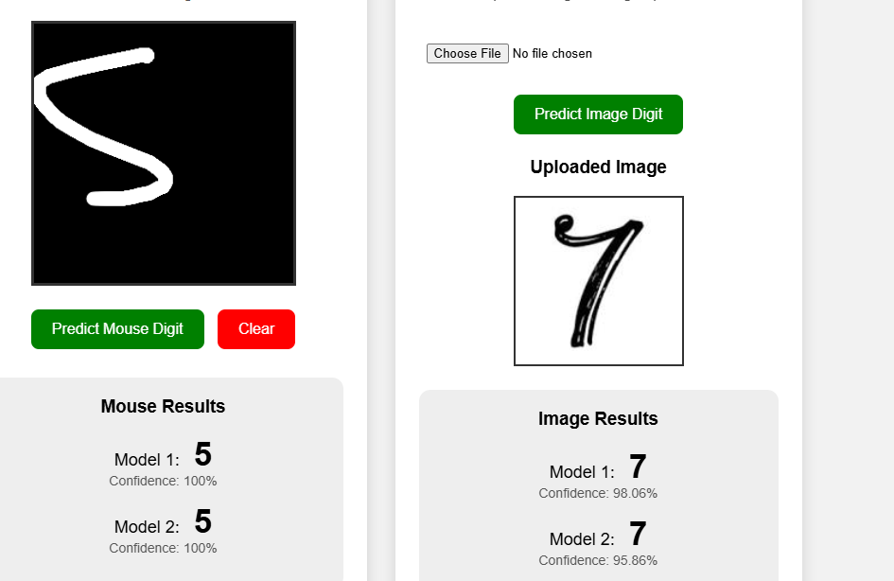
2.
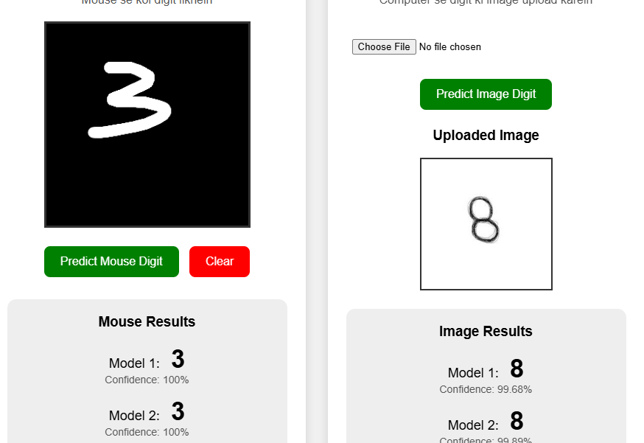
3.
